Name

Mathematics Stage 5 Paths
Compound Events

Book 1 |  | Version: 261007  Feedback:  https://MrDingMaths.com
Contents
Syllabus Content 2
Learning Intention 3

Syllabus Content
MA5-PRO-P-01 solves problems involving Venn diagrams, 2-way tables and conditional probability
Solve problems involving Venn diagrams and 2-way tables
- Represent and interpret data in Venn diagrams for mutually exclusive and non-mutually exclusive events
- Construct Venn diagrams to represent all possible combinations of 2 attributes from given or collected data
- Interpret data in 2-way tables to represent relationships between attributes
- Construct 2-way tables to represent the relationships between attributes
- Convert between representations of the relationships between 2 attributes in Venn diagrams and 2-way tables

Interpreting Venn Diagrams and Two-Way Tables

- Mutually Exclusive Events
Mutually Exclusive  Mutually exclusive events cannot occur at the same time.  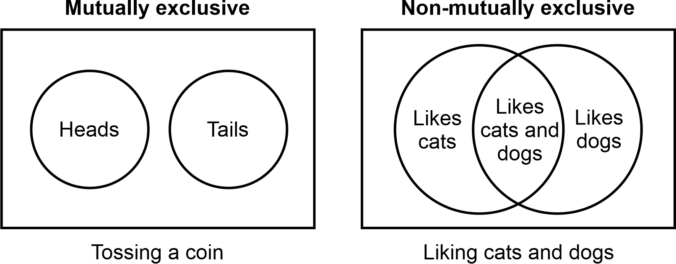  The Venn diagram does not overlap. | Non-mutually exclusive  Non-mutually exclusive events can occur at the same time.  The Venn diagram overlaps.

- Identify events as mutually exclusive or not.
- Liking maths, liking science  - Mutually exclusive  - Non-mutually exclusive | - Liking maths, not liking maths  - Mutually exclusive  - Non-mutually exclusive
- Even number, odd number  - Mutually exclusive  - Non-mutually exclusive | - Owning a dog, owning a cat  - Mutually exclusive  - Non-mutually exclusive
- Vowel, consonant  - Mutually exclusive  - Non-mutually exclusive | - Tossing a head, tossing a tail  - Mutually exclusive  - Non-mutually exclusive
- Having a tail, having four legs  - Mutually exclusive  - Non-mutually exclusive | - Winning a game, not winning a game  - Mutually exclusive  - Non-mutually exclusive

- Venn Diagrams and Two-Way Tables
Venn diagrams and two-way tables show two events and their overlap.
Tea
Coffee
7
3
5
10
 | Likes Tea | Dislikes Tea | Total
Likes Coffee | 7 | 3 | 10
Dislikes Coffee | 5 | 10 | 15
Total | 12 | 13 | 25

- Interpret Venn diagrams and two-way Tables
The Venn diagrams below represent a group of people who were surveyed on whether they like tea and coffee. Shade the area on the Venn diagram and two-way table that represents:
Shade the area on the Venn diagram and two-way table that represents:
- People who like tea  T  C | - People who like coffee
   | T | Not T | Total
  C
  Not C
  Total
   | T  T  C | Not T | Total
  C
  Not C
  Total
- People who like tea only  T  C | - People who like coffee only
   | T | Not T | Total
  C
  Not C
  Total
   | T  T  C | Not T | Total
  C
  Not C
  Total
- People who like both tea and coffee  T  C | - People who like tea or people who like coffee
   | T | Not T | Total
  C
  Not C
  Total
   | T  T  C | Not T | Total
  C
  Not C
  Total
- People who don’t like tea  T  C | - People who don’t like coffee
   | T | Not T | Total
  C
  Not C
  Total
   | T  T  C | Not T | Total
  C
  Not C
  Total
- People who like neither tea nor coffee  T  C | - Everyone surveyed
   | T | Not T | Total
  C
  Not C
  Total
   | T  T  C | Not T | Total
  C
  Not C
  Total

- Example Interpret Venn diagrams and two-way tables.
A survey was conducted to see people’s preferences on tea and coffee.
 | Coffee | Not Coffee | Total
Tea | 20 | 10 | 30
Not Tea | 15 | 5 | 20
Total | 35 | 15 | 50

How many students:
- Were surveyed in total? 50 | - Like tea and coffee? 20
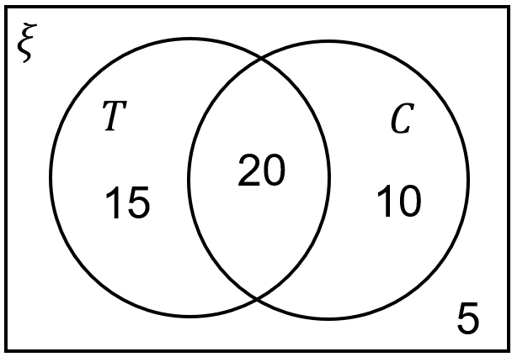  - Like tea or like coffee? 45 | - Like neither tea nor coffee? 5
- Like coffee only? 10 | - Like tea only? 15
- Like tea? 35 | - Like coffee? 30
- Dislike coffee? 20 | - Dislike tea? 15
What is the probability that a randomly selected person:
- Likes coffee?  $$P\left(T\right)=\frac{30}{50}=\frac{3}{5}$$ | - Likes tea and coffee?  $$P\left(T\right)=\frac{20}{50}=\frac{2}{5}$$

- Example Interpret Venn diagrams and two-way tables.
A survey was conducted to see people’s elective subjects.
 | Chinese | Not Chinese | Total
Art | 9 | 12 | 21
Not Art | 21 | 8 | 29
Total | 30 | 20 | 50
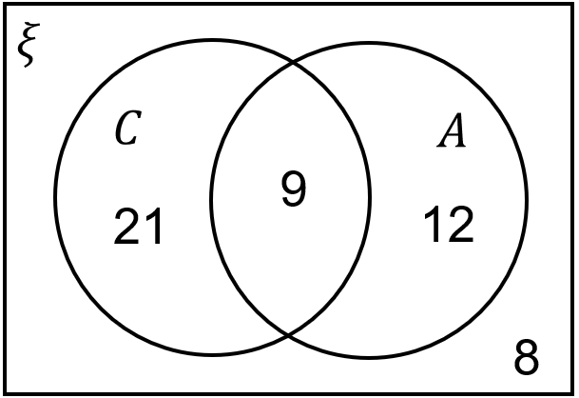

How many students:
- Were surveyed?  50 | - Take Chinese and art?  9
- Take Chinese or art?  42 | - Take neither Chinese nor art?  8
- Take Art only?  12 | - Take Chinese only?  21
- Take Art?  21 | - Take Chinese?  30
- Don’t take Chinese?  20 | - Don’t take art?  29
What is the probability that a randomly selected person:
- Takes Chinese?  $$\frac{30}{50}=\frac{3}{5}$$ | - Takes art only?  $$\frac{12}{50}=\frac{6}{25}$$

Foundation
- The results of a survey of sports students play is shown in the Venn diagram below.
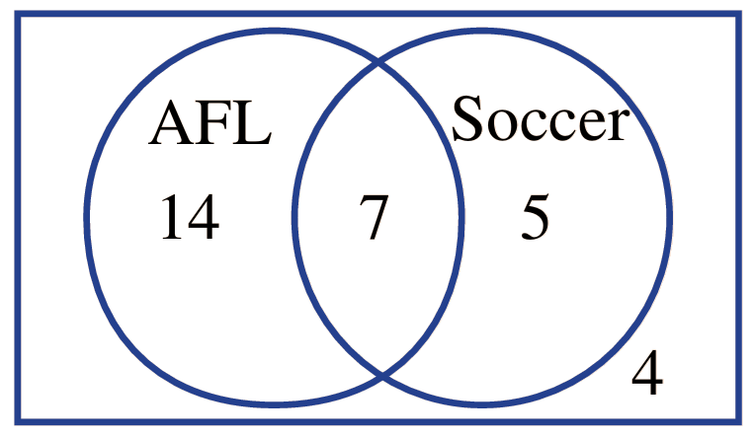

How many students:
- were surveyed?  30 | - play both AFL and soccer?  7
- play neither AFL nor soccer?  4 | - play soccer?  12
- play AFL?  21 | - play AFL only?  14
- don’t play AFL?  9 | - don’t play soccer?  18

- At a car yard, cars were surveyed to see whether they are petrol cars or electric cars.
 | Electric | Not Electric | Total
Petrol | 3 | 15 | 18
Not Petrol | 5 | 1 | 6
Total | 8 | 16 | 24
How many cars:
- were surveyed?  24 | - are both petrol and electric?  3
- are neither petrol nor electric.  1 | - are petrol or electric?  23
- are not electric?  16 | - are electric?  8
- are petrol only?  15 | - are electric only?  5

- For each Venn diagram, find the probabilities.
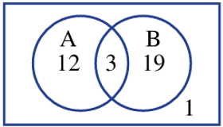  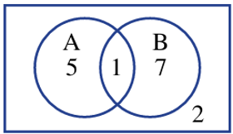  $$P\left(A\right)$$  $$\frac{2}{5}$$  $$P\left(A only\right)$$  $$\frac{1}{3}$$  $$P\left(not B\right)$$  $$\frac{7}{15}$$  $$P\left(A and B\right)$$  $$\frac{1}{15}$$  $$P\left(A or B\right)$$  $$\frac{13}{15}$$  $$P(neither A nor B)$$  $$\frac{2}{15}$$ | $$P\left(A\right)$$  $$\frac{3}{7}$$  $$P\left(A only\right)$$  $$\frac{12}{35}$$  $$P\left(not B\right)$$  $$\frac{13}{35}$$  $$P\left(A and B\right)$$  $$\frac{3}{35}$$  $$P\left(A or B\right)$$  $$\frac{34}{35}$$  $$P(neither A nor B)$$  $$\frac{1}{35}$$

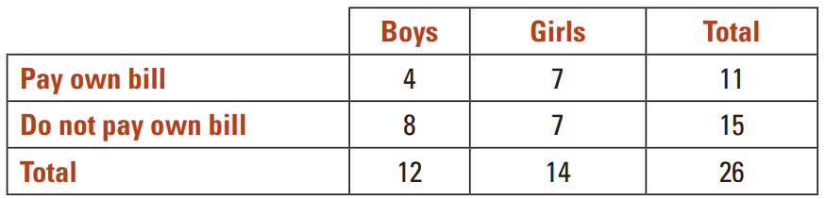
- The two-way table below shows the results of a poll conducted of a group of students who own mobile phones to find out who pays their own bills.

  - How many students participated in this poll?
26
  - How many participants were boys?
12
  - How many of the students surveyed pay their own bill?
11
  - Find the probability that a randomly selected participant:
    - is a boy who pays his own bill
$$\frac{2}{13}$$
    - is a girl who pays her own bill
$$\frac{7}{26}$$
    - is a girl
$$\frac{7}{13}$$
    - does not pay their own bill
$$\frac{15}{26}$$

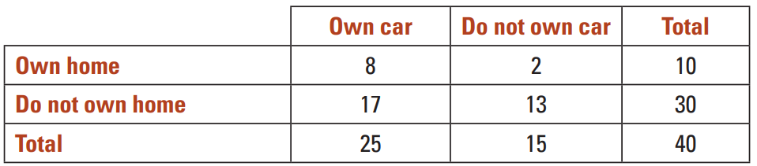
- Forty men completed a survey about home ownership and car ownership.
The results are shown in the two-way table below.

If a survey participant is chosen at random, give the probability that:
  - he owns a car and a home
$$\frac{1}{5}$$
  - he owns a car but not a home
$$\frac{17}{40}$$
  - he owns a home
$$\frac{1}{4}$$

- For each diagram, find the following probabilities.
You will need to calculate the total number in the sample first.
A  B  1  7  5  2  - $P\left(A\right)=$ $\frac{6}{15}$ $=$ $\frac{2}{5}$  - $P\left(A only\right)$  $$\frac{1}{3}$$  - $P\left(not B\right)$  $$\frac{7}{15}$$  - $P\left(A and B\right)$  $$\frac{1}{15}$$  - $P\left(A or B\right)$  $$\frac{13}{15}$$  - $P\left(Neither A nor B\right)$  $$\frac{2}{15}$$ | - $P\left(A\right)$  $$\frac{3}{7}$$  - $P\left(A only\right)$  $$\frac{12}{35}$$  - $P\left(not B\right)$  $$\frac{13}{35}$$  - $P\left(A and B\right)$  $$\frac{3}{35}$$  - $P\left(A or B\right)$  $$\frac{34}{35}$$  - $P\left(Neither A nor B\right)$  $$\frac{1}{15}$$
   | A | Not A | Total
  B | 3 | 19 | 22
  Not B | 12 | 1 | 13
  Total | 15 | 20 | 35

Mastery
- Zilda took a survey of eighteen year olds, asking if they work, go to school, do both or neither.
The Venn diagram shows the results.
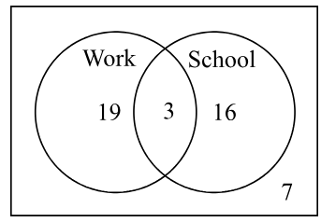
What is the probability that a person randomly selected goes to school and works,
rounded to three decimal places?

0.067
- 2014 HSC Standard 2 Band 3
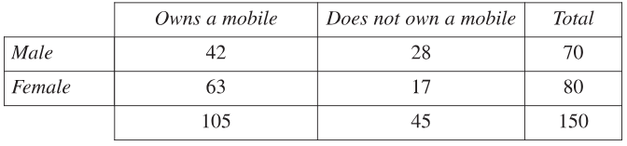
A group of 150 people was surveyed and the results recorded.
A person is selected at random from the surveyed group.

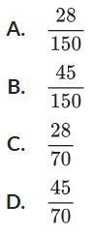
What is the probability that the person selected is a male who does not own a mobile?

A
- 2016 HSC Standard 2 Band 6
A group of 485 people was surveyed. The people were asked whether or not they smoke.
The results are recorded in the table.
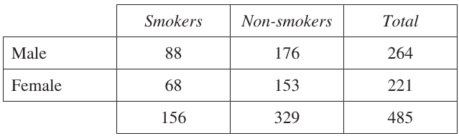

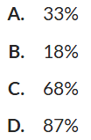
A person is selected at random from the group.
What is the approximate probability that the person selected is a smoker OR is male?

C
- A school surveyed 120 of its students about the type of animals they have at home. The results are recorded in the Venn diagram below, although the number of students who only own horses is missing.
If one of the students is selected at random, what is the probability that the student does not own a goat?
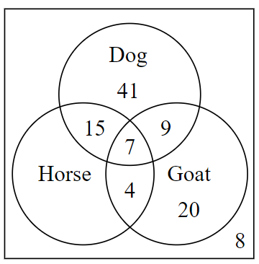

$$\frac{2}{3}$$

- 2010 HSC Standard 2 Band 4
A group of 347 people was tested for flu and the results were recorded.
The flu test results are not always accurate.
A person is selected at random from the tested group. What is the probability that their test result is accurate, to the nearest per cent?
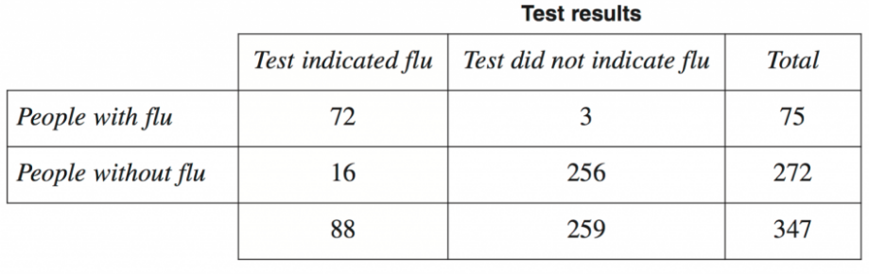

95%

Constructing Venn Diagrams from a Scenario

- Constructing Venn Diagrams from a Scenario
- Read the entire scenario and identify what is given.
- Place “A only, “B only”, “both”, “neither” in its region.
- Find missing values by subtraction.

- Construct Venn diagrams from a scenario.
12 friends are at a party.
9 people eat chicken nuggets.
6 people eat salad.
2 people eat neither.
- Draw a Venn diagram and two-way table to represent this information.
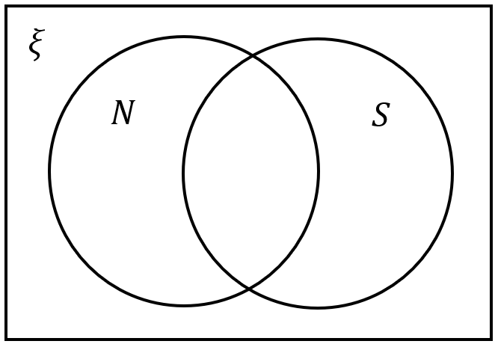
 | S | Not S | Total
N
Not N
Total
- Find the probability that a randomly chosen person ate both.

There are 30 girls in a class.
13 play tennis.
23 play netball.
7 girls play both.
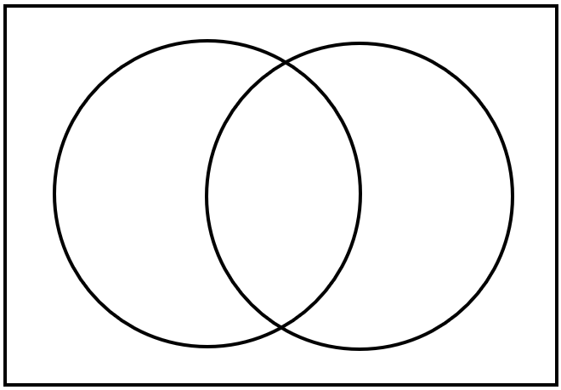
- Draw a Venn diagram to represent this information.
Total
Total

- What is the probability that a girl chosen at random plays neither sport?

Foundation
- Finish these Venn diagrams with the given information.
- 15 students are asked whether they use Tiktok and Spotify. 7 use TikTok, 10 use Spotify and 2 students don’t use either. | 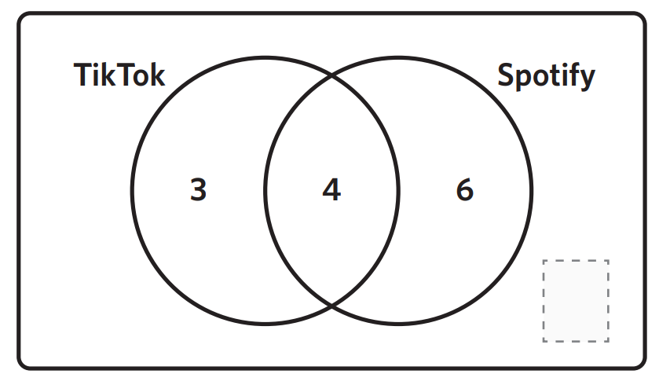  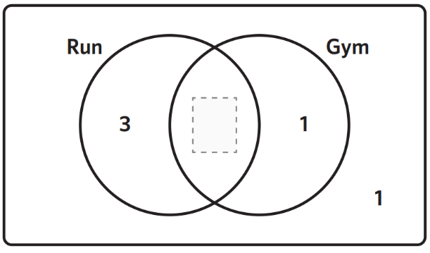  - 30 athletes are asked whether they run or go to the gym as part of their training. 27 run, 25 go to the gym and 1 person, who is injured, says that they do neither.
- 28 people are asked whether they are confident​ at ​spelling ​and​ grammar.​  12​ confident​ at ​both,​ 5 ​are​n’t​ confident​ with​ either ​and ​19 ​​confident​ at ​grammar. | - 50 visitors are surveyed on their way out from a waterpark. 23 people went on The Claw, 30 people went on the Taipan and 11 people did not go on either.  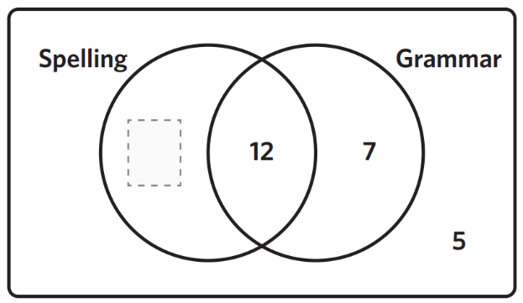  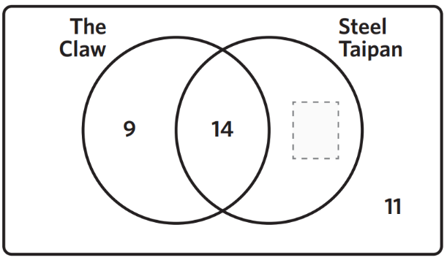

- Fill in the missing numbers in these tables.
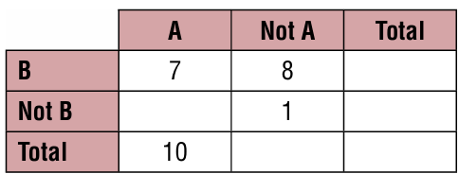 | 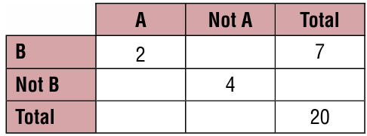

- Convert between these Venn diagrams and two-way tables.
Swim
Bowl
11
20
34
5
 | Swim | Not Swim | Total
Bowl
Not Bowl
Total
GPS
4-door
25
3
42
12
Black
hair
Brown
Eyes

 | Black hair | Not black hair | Total
Brown eyes | 11 | 6 | 17
Not brown eyes | 5 | 8 | 13
Total | 16 | 14 | 30
Boy
Like carrots

 | Likes carrots | Dislikes carrots | Total
Boy | 75 |  | 200
Not boy |  | 40
Total | 145

B
A
2

 | A | Not A | Total
B |  |  | 8
Not B
Total |  | 7 | 12

B
A

9

 | A | Not A | Total
B |  | 4
Not B |  |  | 13
Total | 12

B
A
$$x$$
$$y$$
$$w$$
$$z$$
 | A | Not A | Total
B | $$x$$
Not B
Total | $$x+y$$

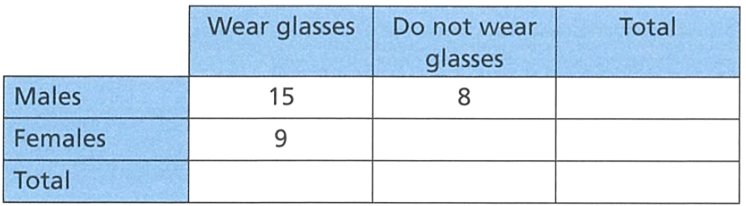
- The table shows information about 50 people at a restaurant. Complete the table.

  - What fraction of the males wear glasses?
$$\frac{15}{23}$$
  - What percentage of the people at the restaurant wear glasses?
$$48\%$$

- The Venn diagram below shows the number of students speaking French and Italian in a classroom of 80 students.
First find the missing information, then find the probability that a randomly chosen student:
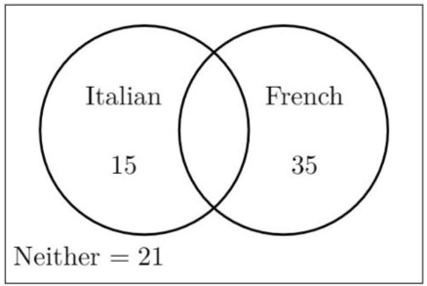
  - Speaks neither French nor Italian.
$$\frac{21}{80}$$
  - Speaks Italian or French, but not both.
$$\frac{5}{8}$$
  - Speaks Italian and French.
$$\frac{9}{80}$$
  - Speaks Italian or French.
$$\frac{59}{80}$$

- The Tourism Council surveyed 130 people to find whether they prefer New South Wales or Queensland as a holiday destination.
NSW: 44 QLD: 66 NSW and QLD: 20
- Complete the Venn Diagram

- Calculate $P(NSW and QLD)$
$$\frac{2}{13}$$
- Calculate $P\left(NSW only\right)$
$$\frac{12}{65}$$
- Calculate $P(neither NSW nor QLD)$
$$\frac{4}{13}$$
- In a group of 50 students, there are 26 who study Latin, 15 who study Greek and 8 who study both languages. Draw a Venn diagram and find the probability that a student chosen at random:
  - studies only Latin,
  - studies only Greek,
  - does not study either

$$a)\frac{9}{25}$$
$$b)\frac{7}{50}$$
$$c)\frac{17}{50}$$
- Each student in a music class of 28 studies either the piano or the violin or both. It is known that 20 study the piano and 15 study the violin. Find the probability that a student selected at random studies both instruments.

$$\frac{1}{4}$$
- 120 children are asked how they travel to school.
Two-thirds of those asked are boys.
26 girls walk to school.
Twice as many boys don’t-walk to school as girls.
Use a two-way table to work out how many boys walk to school.

52

- 2007 HSC Standard 2 Band 4
Leanne copied a two-way table into her book.
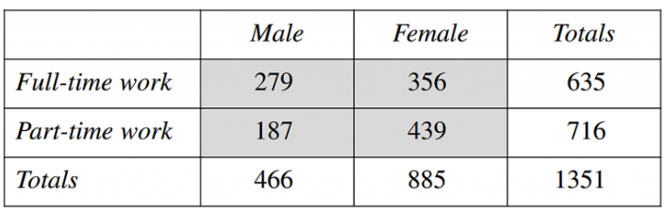

Leanne made an error in copying one of the values in the shaded section of the table.
Which of the four values has been incorrectly copied?

439

Mastery
- Of 15 courier companies:
9 offer a local service (L), 7 offer an interstate service (S) and 6 offer an international service (I). 2 companies offer all three services, 3 offer both local and interstate services, 5 offer only local services and 1 offers only an international service.
  - Complete the Venn diagram to display the given information.
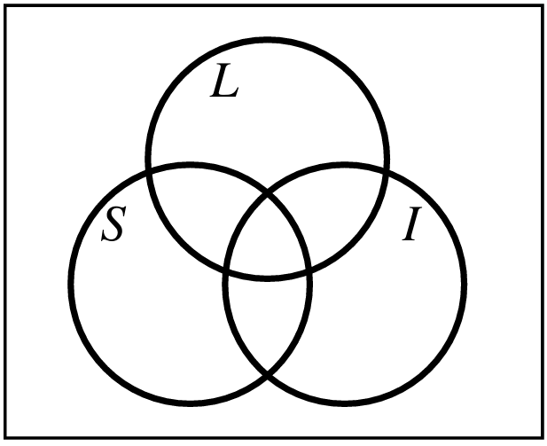
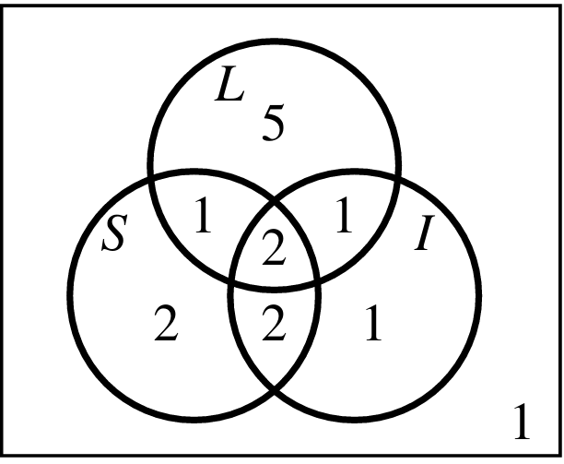

  - If a courier is chosen at random from the 15, find these probabilities:
- $P\left(L\right)$  $$\frac{3}{5}$$ | - $P\left(L only\right)$  $$\frac{1}{3}$$ | - $P\left(L or S\right)$  $$\frac{13}{15}$$ | - $P\left(L and S only\right)$  $$\frac{1}{15}$$

- 58 people took a trip to Europe to visit either France, England or Spain. Of this group,
26 visited France, 38 visited England, 29 visited Spain, 10 visited France and Spain,
12 visited only Spain, 13 visited only England and 8 visited all three countries.
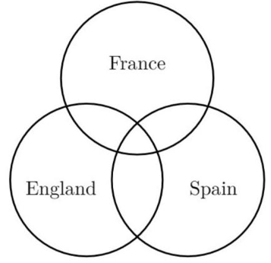

A person from the group of 58 was chosen at random. What is the probability that the person:
- Visited France only  $$\frac{3}{29}$$ | - Visited England and France  $$\frac{9}{29}$$ | - Visited only one country?  $$\frac{31}{58}$$

- Thirty-eight people were interviewed about their travelling experience in the past 12 months. The interviewer remembers the following information.
- 2 people travelled overseas, interstate and within their own state.
- 2 people travelled overseas and within their own state only.
- 7 people travelled interstate only.
- 22 people travelled within their own state.
- 3 people did not travel at all.
- The number of people who travelled interstate and within their own state only was twice the number of people who travelled overseas and interstate only.
- The number of people who travelled overseas was equal to the number of people who travelled within their own state only.
  - Fill in the Venn diagram.
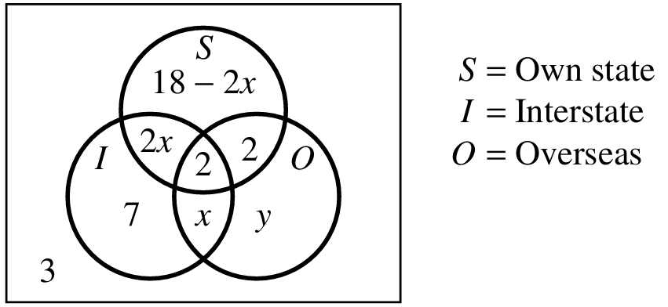
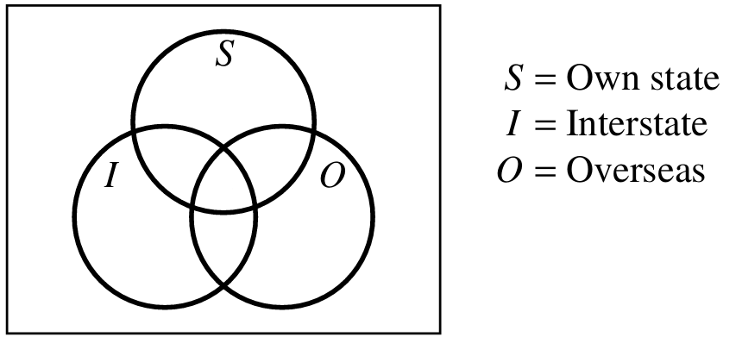

  - Let $x$ be the number of people two travelled overseas and interstate only.
Let $y$ be the number of travelled overseas only.
Solve simultaneously to find $x$ and $y$

$$x=4, y=2$$
  - If one person from the 38 is chosen at random, find the probability that they have travelled:
    - Within their own state only
$$\frac{5}{19}$$
    - Overseas only
$$\frac{1}{19}$$
    - Interstate only
$$\frac{7}{38}$$
    - Overseas or interstate or within their own state
$$\frac{35}{38}$$
    - Interstate or overseas
$$\frac{25}{38}$$

